My Past and Thoughts

For these reflections, I am trading shamelessly on the memoirs of Alexander Herzen, intellectual father of all Russian socialists, which are similarly titled 'My Past and Thoughts'. Herzen rambled on for four volumes' worth, in some editions. I will be far briefer, but apologize in advance for being too windy for some readers. After seventy years of living through twentieth and twenty-first century history, and after nearly fifty years of college teaching, here goes.

There are innumerable definitions of history and descriptions of being made to study it, from Henry Ford's "bunk" and Mark Twain's "a pack of tricks played on the dead" to the famous Santayana phrase about being fated to repeat it if you neglect its study. Then there's Sam Cooke's "don't know much about the Middle Ages, looked at the pictures as I turned the pages," and Bob Dylan's take on the First World War... "it came and it went, the reason for fighting I never did get."

These are just a few famous "thoughts" about history. I don't really have any of my own to stack up against those above, except to say that my "past" heavily governed--I would stop short of dictated--my arrival in front of a classroom of freshman wanna-be engineers at North Carolina State University in late August or very early September (can't remember which) 1968. LBJ was president. Jimi Hendrix was revolutionizing rock music. I was just about to turn twenty-three.

How I got there

Life has taught me that the old canard about the apple not falling far from the tree is sometimes true. My mother was a teacher (but not a history teacher). My father was a great reader of history (but not a teacher). I became a history teacher.

It was always assumed I would go to college, though only my mother had done so. It was more or less assumed, by the time I was in my early teens, that I would study science or engineering. I went along with these plans by trying to excel in science and math.

The first episode of history I knew about was World War II. My father had participated and, as I used to inform my nine year old friends, "won it". My mother, overhearing this, later gently broke the news to me that it wasn't quite that simple. My first lesson in the complexity of history.

A few years later, I can recall being as puzzled as Sam Cooke by a school lesson about the Middle Ages. One evening, my father patiently explained the basics to me as I sat on the floor near his thread-bare easy chair in our small living room. An early encounter with good teaching.

[books and magazines?]

Three Big Memories

During my childhood, mostly spent in Orlando and DeLand, Florida, there were three big Cold War events that are forever etched in my memory:

In October 1957, the USSR launched the first earth satellite, **Sputnik One**. This was the greatest triumph of the entire not-quite seventy-five years of Soviet history. Can't recall any details, but do recall discussing it with my father. The best English language telling of the story, by Paul Dickson, calls it "the shock of the century".

Six years later, when faced with a high school senior research paper, I chose to write about how the U.S. effort had fallen short. By then, we were living in DeLand, Florida and I researched the topic primarily in periodical runs housed in the library of Stetson University. The main failing stemmed from the Department of Defense taking the project away from the Army, and the former Nazi scientist Werner von Braun (who had designed the V-2 rocket) and awarding it to the Navy. This is what is called in tennis an unforced error, and one of the classic examples of why you do not swap horses in the middle of a stream. The re-start resulted in the Vanguard missile as launch vehicle, instead of the Army's Redstone, a reworking of von Braun's V-2. The switch came around 1954-55 and slowed the U.S. effort.

Then, as now, the principle U.S. launch site was Cape Canaveral. From our Orlando back yard, thirty miles due west, I had watched the failure and explosion of various Ajaxes and Jupiters, which usually reached no more than several hundred yards above the launch pad before swerving erratically and being exploded by ground control. Rocket science was literally in its infancy, and failure was a commonplace.

So, the Russians got it done first, which caused a Cold War shiver like no other. If their rockets could launch an object into space, they could potentially launch an atomic payload targeting the U.S.

One thing that did not launch was the Vanguard missile. It sat passively on its pad through numerous delays and countdown holds. One evening, I think early December, my parents loaded me into the car and we drove to Cape Canaveral to watch one of the scheduled launch attempts. In those days you could drive to within view of the missile itself without any security checks. We sat, and sat some more, and then some more in our car until the wee small hours. Nothing. We drove home.

A few days later, when the countdown finally culminated, the Vanguard lifted itself a few feet and promptly exploded. The Army was asked to take over and hustle together a January launch using von Braun's Jupiter-C rocket, a further development of the old, early-1940s German V-2. It put the first U.S. satellite into orbit in late January 1958.

Well, this brought a sigh of relief at least momentarily. We had, in a way, caught up to the Russians. Soon, however, the Russians began to launch heavier and heavier satellites, including one carrying a dog. Cool, in a way, but scary for U.S. strategic thinkers (and newspaper headline writers) because it reinforced what seemed a clear Russian advantage in rocketry.

U.S. education was among the areas affected by the fear that ensued. I was already doing frequent "duck and cover" drills in school, and occasionally all us students were packed into cars and buses and driven out into the pine barrens and orange groves several miles away from our elementary school. I think this was because of the B-47s and B-52s at Orlando's Pinecastle Air Force base, which the Russians would surely attempt to bomb in the event of the unthinkable.

If the unthinkable turned out to be an incoming missile instead of bombers, there would not be time to be driven to the orange groves, which in any event would offer no safety from a nuclear bomb likely to turn the whole area into a radioactive crater lake.

What had a greater impact on me than these absurd drills was the creation of an accelerated program of studies in my junior high school. A few months later, all of us seventh graders were asked to take the pre-SAT test. Those who scored highly, including myself, were vaulted over eighth grade science and math and instead took algebra and a souped-up science course. The latter included special sessions with local and Cape Canaveral rocket scientists and engineers and visits to things like the linear accelerator at the University of Florida. This all reinforced my naive understanding that college was important and that I should study engineering.

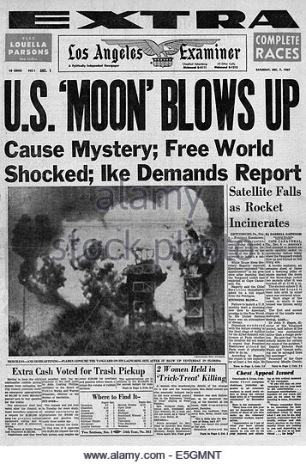

***

A few years passed. NASA was formed, the notorious 1960 election phrase "missile gap"--which asserted we were still behind the Russians--was held to be gospel by most Americans, and--in the summer of 1961--the Russians built the **Berlin Wall**. This was the second big headline grabber for Soviet Russia during my teen years.

Actually, it was the East Germans who built the wall, and they may have done so to the chagrin of Khrushchev and the Soviet government, but a confrontation did take place a few months later when U.S. and Soviet tanks actually pointed their guns at each other in Berlin--a true "high Noon" moment in the Cold War if there ever was one.

And the whole process of building the wall was televised. First came the barbed wire. Then came the actual masonry of the wall. During these weeks and months, dozens, maybe hundreds, of would-be defectors were shot trying the climb or swim their way to the Western zones of Berlin. It was the rising tide of defections, and the fact that it was mostly the young and talented that were fleeing, that prompted the wall's erection.

Seeing all this on TV was riveting to say the least. And my father decided the crisis made a nuclear exchange much more likely. He, my mother, and I attended some "civil defense" classes. These were popular during the Cold War, and they took "duck and cover" to another level. In the classes, you learned how to read a Geiger counter, a device to measure radiation. I think we actually bought a few pocket-sized devices. And it was recommended that kids have military-style dog tags for identification. Identification, that is, of one's corpse. Right, very scary. I had one of these.

The best part was that my family also considered building a backyard bomb shelter. This was the last word in protection, it was said. Bulldoze your backyard and plant a room-sized, pre-fab shelter below about three feet of earth. There was a hand-cranked ventilation system, the shelter would be stocked with food and water, a radio, etc. Well, for a teenager, this was beautiful. I did all I could to encourage the idea, in hopes of making it my room until disaster struck. Sure, the concept was lunacy, and we couldn't afford it in any event, but I was now convinced at age fifteen that the Soviet Union was definitely not just powerful (proven by Sputnik), but also a determined enemy.

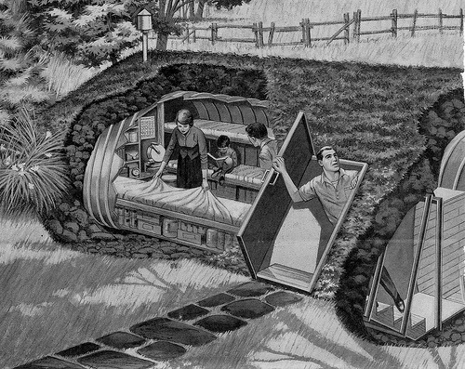

***

The **Cuban missile crisis** came little more than a year later, October 1962. This truly was the "eyeball to eyeball" moment of the Cold War, wherein--as Dean Rusk (Kennedy's secretary of state) reportedly said--the other guy blinked first. Cuba was very close to Florida--90 miles to the south. Since its 1958-59 revolution, it had been an anti-U.S., and increasingly pro-Soviet, bastion. Cuba's leader Fidel Castro, like Mao Zedong, was goading Khrushchev to play hard ball with the Americans. After all, with Russia's perceived advantage in missilery, why not?

Khrushchev, a basically sane and cautious leader, was sometimes prone to the bold stroke. When he was removed from power two years later, those who ousted him termed his succession of failed plans and projects "hare-brained schemes". The last straw was his apparent intention to launch an air strike on China's nearly operational atomic test site to prevent them from becoming a nuclear power.

But the Cuban fiasco was perhaps the largest and most embarrassing of his failures. Placing nuclear-tipped medium range missiles in Cuba was truly a bold gamble, and one he lost. Thirteen days of incredible tension led to a humiliating withdrawal of the Russian missiles. In my humble opinion, the Soviet Union would never recover from this moment and would never again seem so globally powerful.

As a seventeen year-old, I remember these thirteen days because of:

watching, with my parents, one or two of the televised speeches made by President Kennedy about the completely unexpected crisis,

seeing the main street of our small town, which was in these pre- interstate highway days, one of Florida's primary north-south highways, literally gridlocked by military convoys staging themselves in central and south Florida preparatory to an invasion of Cuba,

worrying that my parents might not let me drive to an out of town Friday night football game during the crisis,

experiencing, in the aftermath, one of only two childhood nightmares that I recall vividly to this day--a Soviet submarine popping up in the lake next to our home.

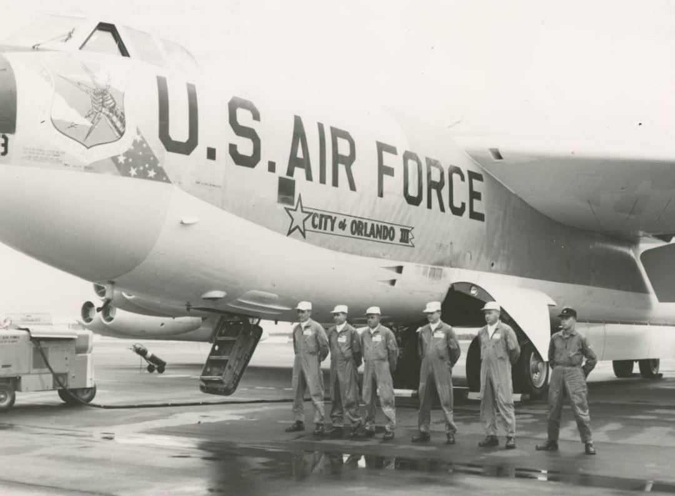

Undergraduate Studies--University of Florida

As a freshman at the University of Florida, I was enrolled in the invitational honors program. Classes were small and profs were from the university's elite. Besides some interdisciplinary honors courses, I was enrolled in calculus and engineering drawing (or drafting). My declared major was aeronautical engineering.

The summer after graduating high school, I worked for a small airplane manufacturing company in my home town. Some rock bands have started in garages, as well as world-famous companies (Apple). You've never heard of this company and I'll spare you its name. The owner, my boss, ran his business out of a pair of tee hangars, the aircraft industry equivalent of a two-car garage. I did a little bit of everything: drafting, riveting, metal fabrication, and I also swept the place out every evening. All this was educational and had the effect of blunting my interest in both airplanes (I never wanted to fly around in one I had helped build) and engineering (it seemed boring).

Still, I was an engineering major, with aeronautical engineering my declared field. The classes that interested me more were my honors seminars. These were interdisciplinary humanities and social science classes. I remember very little about them apart from a few of the books we read--Freud, Dostoevsky, Eric Fromm, Jacques Barzun, Bertrand Russell. I still have a few of these. I began to imagine a life spent like my profs in these classes: wearing silk ties and tweeds, with nice shoes, talking about interesting stuff to students in a wood-paneled seminar room. My engineering profs wore pocket protectors, carried slide rules, and gave uninteresting lectures to auditorium-sized classes. [need something about Woolf bringing Dean Holingshead to one of our seminars; showed me that the university had non-teaching administrators who cared about students and classroom teaching]

Halfway through my freshman year, I changed my major to history. I considered this a sort-of holding action in lieu of really knowing what I wanted to do. I knew I didn't want engineering, and was uncertain about alternatives. I can recall thinking at the time... well, history always interested my father. For the moment, this was good enough for me, too.

My first history classes at the U of F were Western Civ and intro U.S. history. It's been so long I can barely remember the profs names (but both were prominent: one was current chair of the Department of History and I think the other was a former chair). Both classes were quite large and featured forgettable lectures... probably this is the real reason I struggle to recall the professors' names. And I was largely going through the motions without anything approaching enthusiasm.

In a later semester, fall term of my third year, I again took two simultaneous classes in history: Western Civ, part two, and U.S. history, part two. Again, pretty big lecture sections, especially in the case of U.S. history (so big that the prof's graduate assistants took the roll and--I think--graded the exams). This time, both professors were memorable and positive role models.

**Clifton Yearley** was my U.S. history prof. The thing about him was that he was very entertaining. Some of my fraternity brothers were also in this class, and we would usually walk back to the frat house after this afternoon class retelling his anecdotes and humorous asides about historical events. The funniest thing I recall was not a story or anecdote, but something he did. Pacing back and forth across the dais as he lectured, he made an emphatic point as he walked behind the lectern, over which his sport jacket was draped. As he raised his voice climactically, he pounded his fist on the lectern (and jacket) for effect. Taking one or two more steps, he stopped and looked back at the lectern. Returning to it, he picked up the jacket and shook it. A broken pair of sunglasses tumbled out.

Yearley lectured with a light touch, without notes, and with humor. I liked all of this, and his was my most memorable U of F class, period. Never had any real interaction with him, however.

During the same semester, my Western Civ prof was **Max Kele**. He was considerably younger than any of my other history instructors, and may have been in his very first year at the university. I recall he was ABD (all but dissertation); that is, not quite yet a PhD. His lectures were pretty standard in style and substance, but the subject matter (basically Europe since the Renaissance) held more appeal to me than any history class heretofore.

This was a very long time ago, so memories of Yearley and Kele are not great, more like impressions. My impression of Kele was that here was someone in whose shoes I could imagine myself. First time this happened to me with a college prof. He was young and approachable after class. He had a wife and baby and a shiny new Plymouth (I guess I do recall some things clearly) and his family would sometimes be waiting for him after my afternoon class dismissed.

Another thing about Kele was that, as a young ABD, he often talked about his major professor and dissertation advisor, John Snell. I think he greatly admired Snell, who was an imminent historian of modern Germany at Vanderbilt University. If I recall, he would often acknowledge Snell when lecturing on twentieth century topics to my class. He lectured from notes, but his lectures were freshly written and animated.

And here's the most memorable thing about Kele and Snell. Kele brought Snell to the U of F for an invited, evening lecture (topic escapes me) in Memorial Auditorium. Now nothing in Florida is old, at least not by any normal historical standard. Memorial Auditorium was built (just looked it up) in 1924, but is a beautiful Gothic revival structure with no less impressive interior. A beautiful place in which to hear a memorable speaker. I never forgot what I thought was this very appropriate, but equally touching, thing that Kele did by bringing the man to whom he owed so much to our campus. For me, it was also my first up close look at a widely known and published historian, and I was impressed.

During this same fall semester, I also heard an announced lecture in Memorial Auditorium by Roy Wilkins, executive director of the NAACP. Wilkins was at that moment a civil rights leader equal in stature to Martin Luther King, and had been an advisor to both President Kennedy and Johnson. Again, can't remember his words, but I never forgot his calm and persuasive manner.

I was beginning to figure things out. Maybe being a history major could lead to a career as a college or university professor. The lifestyle seemed attractive, as did the work itself. Certainly graduate school and advanced degrees would be required. So far, my commitment to diligent study and preparation for my classes, irrespective of whether engineering or liberal arts, had been sporadic. I decided that truly committing to any academic major would require moving out of my fraternity house, leaving behind the scene of the crime.

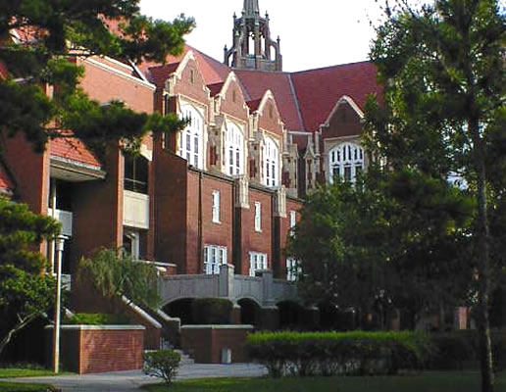 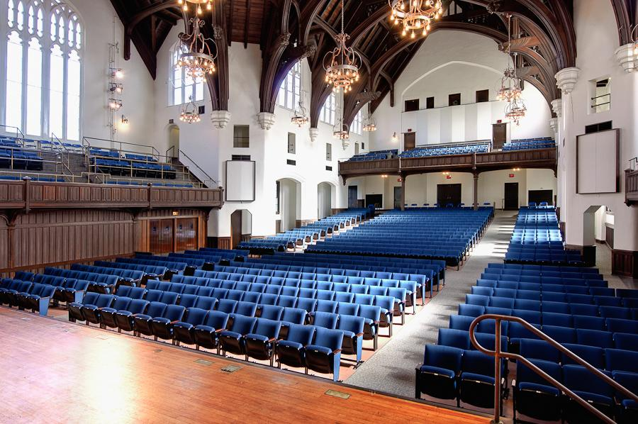

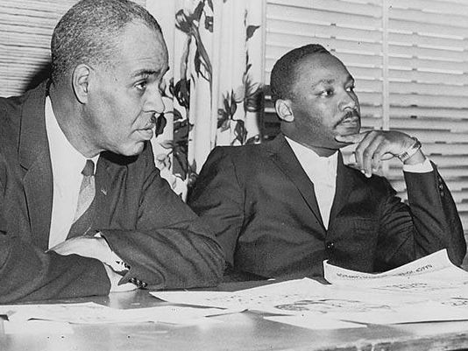

Undergraduate studies--Stetson University

Stetson University, which was in reality a small liberal arts college, was in my hometown of DeLand, Florida. I had dismissed attending it until now, but felt that a semester there could reinforce and solidify my academic commitment. I chatted with Kele about this, and he did not try to dissuade me. I fully expected, after a one-semester cure, to return to the University of Florida.

My plan, such as it was, for a semester at Stetson involved trying to enroll for two history and two English literature courses. During my last semester at UF, I had taken a course in the American novel (18th-19th centuries) and found that I enjoyed it. The professor, Harry Warfel, was a dead ringer for Col. Sanders of fried chicken fame, and the biographer of Charles Brockden Brown, whose 'Wieland' is generally regarded as the very first American novel. So of course we read it, plus Cooper, Hawthorne, Poe, and Melville.

Still a declared history major upon arrival at Stetson, I guess you could say I was now in my undecided phase. What I did decide was to take two English and two history courses during Spring semester 1966 and decide which would be my major. Two courses I knew I wanted were Stetson's courses in Shakespeare and in the history of Russia. I considered the former to be probably the best entree to a lit major. I had so far not taken a 'national survey' history class and where better to start than with the irrepressible Russians who kept popping up, or acting up, on the world stage during my childhood. Plus, Stetson had a renowned prof teaching each subject.

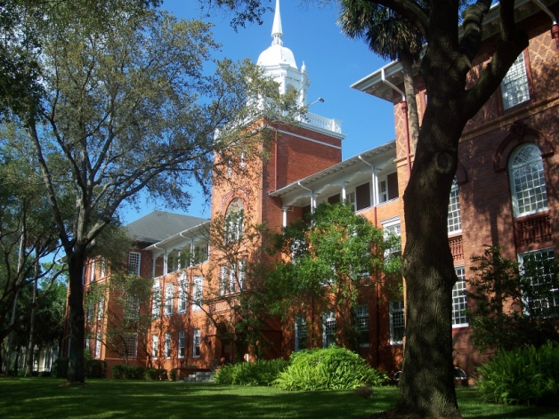 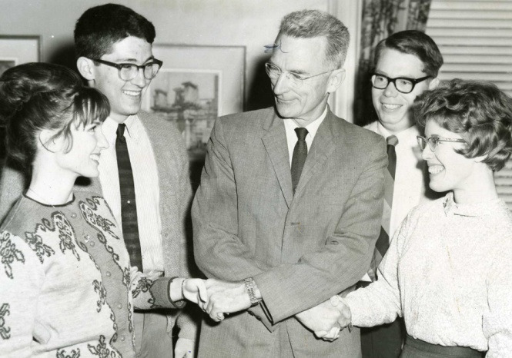

It turned out both of these profs were on leave for Spring 1966. Byron Gibson, the Shakespeare prof, was actually father of one of my high school friends and someone with whom I occasionally had played tennis, so I knew him and already respected him greatly. He also collected British sports cars, including Jaguar and Turner roadsters. My own first set of wheels was a 1950 British MG-TD, so we had another affinity in common. Serge Zenkovsky, the Russian history prof (about whom much more later), was on leave because he had taken a fall from a ladder while picking fruit in his small grove of orange trees. In spite of not being able to study with either of these gentlemen immediately, I did find some good classes, and the semester produced two big results: first, I decided to commit fully to a history major; second, I decided to remain at Stetson to complete by undergrad degree.

During Spring 1966 semester, I enrolled in two history courses and one English lit, since I couldn't also take the Shakespeare course. These were U.S. diplomatic history, history of Africa, and modern British poetry. All three were very good, but the standout was the diplomatic history class. It was taught by the history department chairman, **Gilbert Lycan**, an imposing person and an imposing scholar. I knew this class would be the real litmus test for me and I was determined to do well. Lycan always wore a dark suit, starched shirt and tie, and stood behind a lectern. His presentations were precise and held the attention of everyone in the class of approximately fifteen students. Stetson was a coed institution, but I think all students in this class were male. Some serious history majors (one of whom went on to become a renowned authority on the American presidency and author of more than a dozen books on the subject) and a few members of the baseball team, in search of an elective and probably unaware of what they were getting into.

[need a small para here about the modern Brit poetry class, retaining the Untermeyer anthology, etc]

This was Lycan's signature class. He had studied at Yale with the dean of American diplomatic historians, Samuel Flagg Bemis, and he was the author of a monograph on Alexander Hamilton's influences on U.S. foreign policy. We had two huge, sweat-bullets exams, a midterm and a final, plus a research paper as deliverables. I can remember preparing for the midterm like I never had before: underlining, reams of class and textbook notes, and some back and forth prep sessions with a classmate who became one of my best friends. The result was an excellent score and a big confidence boost.

For the research paper, I chose to write about James G. Blaine, an American secretary of state during the late nineteenth century who championed cooperation amongst Western Hemisphere nations and whose work led to eventual construction of the Panama Canal; I think you could say that Blaine set the pitch for what became known as the "Roosevelt [Theodore] corollary to the Monroe Doctrine... that is, no only should European nations stay out of the affairs of Western Hemisphere nations, but that the U.S.--on the other hand--*would* intervene in them as deemed necessary.

In choosing and developing this topic, I sought Lycan's advice. By then, he had begun to consider me a top student in his class, and he was always generous with his time. He had an air of formality and unapproachability in class and as he walked through campus on his way home (always smoking a big cigar), but when I knocked on his office door, he always had a big smile, and being able to seek his advice meant a great deal to me. He was the first eminent historian and professor with whom I was able to interact. I think I also saw him as something of a father figure, probably more than any other of my profs before or since.

I cloistered myself in Stetson's library to research Blaine, the first time in my college career that I had imposed such a discipline on myself and--to my surprise--I enjoyed the experience. Stacks of books and documents, reams of notes, etc. Not leaving in many cases until the librarians chased me out at closing time. It was a turning point for me.

Well, the paper was a success and I finished out the course with an A, of which I was quite proud. Sometimes, I'd been told, Lycan did not award even one in this class. I later took a research seminar with him. For this, he assigned me "George Washington's religious beliefs". Again, the library became my home. Long story short, Washington's religious beliefs remained opaque, apart from some typical Enlightenment-inspired deist inclinations, to me and as far as I know to all his biographers until now.

I still have several of his books. These include his Hamilton volume, a collection called *Twelve Turning Points in American History*, and his *History of Stetson University*, published after his retirement. All of these are signed to me by the author. I also have a copy of his autobiography, *Mountaineers Are Free* (he was born in the mountain state, West Virginia).

The many conversations we had in his office helped me immensely as I began to take myself seriously as a history major and hoped I was so regarded by my professors. Ten years after leaving Stetson, I paid him a visit. This was 1978, and he was working on his history of the university, published a few years later. We had a pleasant chat and he gave me all the faculty gossip. We had corresponded once in the mid-1970s when I came across an article about Hamilton and sent it to him. Recalling this visit, I think I owe him one more debt of gratitude, since I eventually proposed and then led a group of five historians who compiled and edited the only extant history of my eventual employer, Northern Virginia Community College. This was done, as an oral history compilation, when the college was turning twenty, in the mid-1980s. As I write this, the college is now beyond fifty years of age and no additional compiling or writing of its history as an important, and now mature, institution of higher and post-secondary education has been undertaken.

After about another ten years, we began to correspond again. He had returned to the mountains, not of his native state but those of western North Carolina. Unlike the current moment, when he is literally a Broadway super-star, Alexander Hamilton had more or less fallen out of the conversation about America's founders. He had become, in fact, the forgotten founding father, and Lycan deeply regretted this.

He wanted to write a book that would rehabilitate Hamilton and his legacy. I realized, and imagine he did too, that he was too old to take on such a project. He would be immensely gratified, I am sure, by the attention paid to Ron Chernow's biography of Hamilton published about fifteen years ago. It takes a little imagination on my part, but I have also concluded Lycan would smile in appreciation for what Lin Manuel Miranda has done in his rap/historical musical, which has made "Hamilton" a household word, settles scores with the likes of Jefferson and Burr, and highlights a father-son relationship with Washington.

I also used to smile, once I was a graduate student of Soviet history, a field in which almost anything could be placed in a context of Stalinist and Trotskyite interpretations, when recalling that Lycan could put any early American topic into a Hamiltonian versus Jeffersonian framework. And he would frequently do this in class, in a sort of dialogue with himself that sometimes had us students looking at each other with puzzlement. He was truly "living in the past" (to quote Jethro Tull), and I say this now with nothing but admiration. When my last letter to him went unanswered for a while, I guess it didn't really surprise me when I received word from one of his daughters that he had died. This was 1998, just on the cusp of a rash of good books about Hamilton that would have gladdened Lycan. And I guess I felt a little like Hamilton had when George Washington passed--that a mentor whom I admired and had learned much from was gone forever.

In the fall semester 1966, I enrolled for part one of a two-semester survey of the history of Russia, taught by **Serge Zenkovsky**. It had been my intention to take this class during my first (and at the time I was assuming only) semester at Stetson, and I had announced this plan to Max Kele in one of our discussions, going on to say that since Zenkovsky was clearly Russian himself, I thought he'd be a good choice for the subject. Kele, I recall, cautioned me not to assume there would be a connection between birth place and classroom expertise. As a generality, he was of course correct, but in the particular case of Zenkovsky he was quite wrong. He was a highly idiosyncratic lecturer, but one that I quickly realized was as good as they come.

He was approaching sixty, dressed as did Lycan and most but not all Stetson profs in coat and tie, and was a little over six feet in height. His accent was such that, while not difficult to understand, students nonetheless needed to pay careful attention as he spoke, but his words also held one's attention without difficulty. He had an easy familiarity with and command of his subject, and he lectured very naturally and in a relaxed manner that made his presentations easy to enjoy. I remember the great detail he lavished on the Time of Troubles and the Decembrists, but have no clear recollection of how he handled the 1917 revolution, Lenin and Stalin, etc. These matters were probably too personal and painful for him to relate beyond the basics.

As with Lycan's course, the class size was no more than twenty-five or thirty, in a smallish room that was filled by this number of students. I took both semesters of Zenkovsky's survey of Russia and later took a seminar-style course on World War II which he also taught.

Zenkovsky had been born in Kiev and was ten at the time of the 1917 revolution. In its aftermath, the family wound up in Prague. Long story short, he was eventually trapped there by the Nazi occupation before emigrating to the U.S. His graduate degrees notwithstanding, his first job in New York had been peeling shrimp in a restaurant kitchen. Somehow he soon came to the attention of the dean of Russian history scholars in the U.S., Michael Karpovich, who helped him attain an appointment at Harvard's Russian Research Center. He lectured at the university in the mid-Fifties and Harvard Press published his monograph *Pan-Turkism and Islam in Russia*.

By the early Sixties, Zenkovsky had moved to Stetson, along with his wife Betty Jean, a professor of Russian language. I think it was the fact that Stetson offered them both teaching positions that lured Zenkovsky, but during his time at Stetson he was constantly being courted by universities like Columbia, Wisconsin, and Colorado. He left for Vanderbilt in 1967 and I suspect it had to do with the offer of two teaching positions and also with the fact he would have to do less classroom teaching.

Shortly after his arrival, Zenkovsky had published his translated and edited collection *Medieval Russia's Epics, Chronicles, and Tales*. This was a work of incredible utility and durability. It collected in a pocket-sized paperback numerous documents, most in English translation for the first time, that were indispensable for the study of Russia's history. I think it has never been out of print since original date of publication, and is assigned--in whole or in part--for virtually all introductory courses in Russian history and culture. But Zenkovsky had bigger plans and was only able to realize them after leaving Stetson: translation, editing, and publication of the entire Nikonian chronicle of Russia, which stretched to five volumes published in the 1980s.

Zenkovsky's classes, like Lycan's, confirmed my plan to remain a history major with my sights now on graduate study, probably in modern European history. The lectures of another Stetson prof, Malcolm Wynn, whose courses were surveys of nineteenth and twentieth century Europe, moved me in this direction. Wynn's ability to synthesize and communicate extremely complex events and trends was impressive, and along with many of his other students I was in awe.

It was after I had completed my three classes with him that he brought the daughter of Leo Tolstoi, Alexandra, to Stetson. She had been her father's secretary and caretaker in his last years, and it was with her attending him that he died in the Astapovo train station, having run away from home at age 82. He was a great novelist and humanitarian, but quite mercurial to say the least. Alexandra, herself more than 80 when she came to Stetson in 1967, had left the Soviet Union decades earlier and become a prominent advocate for refugees and immigration reform in the U.S. She established a resettlement center in upstate New York, had been an occasional confidante of Eleanor Roosevelt, and had helped such prominent Russians as Sergei Rachmaninoff and Vladimir Nabokov establish themselves in the U.S. Zenkovsky was a member of her circle and supporter of her charities. Needless to say, her visit was memorable. As has often been commented, in one's college years what happens in classes is important, but campus life and culture are often even more enriching.

Many years later, when reading his autobiography, I discovered that Lycan and Zenkovsky had been close personally. Lycan had been one of those most responsible for bringing Zenkovsky to Stetson. He told Lycan he considered sleepy central Florida "the frontier", and this appealed to him. He and Lycan both took satisfaction in tending small groves of orange trees, and they frequently played chess in each other's homes. According to Lycan, Zenkovsky usually won, but considered their matches competitive and would always have a few cigars on hand, knowing how Lycan enjoyed them. Zenkovsky was often courted by large universities, but resisted leaving for various reasons that Lycan relates. He rejected Columbia because he abhorred the idea of returning to New York City and living in a tall building instead of on a small estate, and he spurned Wisconsin when he was told about the frequent snowstorms.

So I was fortunate he had remained at Stetson long enough for me to have the privilege of studying with him. And it was a truly serendipitous moment when he convinced me to pursue the study of Russia's history as a graduate student.

I had just returned from my summer job in the North Carolina mountains and had walked with three or four friends to one of our favorite lunch spots, a nice buffet-style restaurant none of us could afford more than maybe once or twice a month... but you could go back for seconds and they had great desserts. We had filled our plates and were walking to a table when either I spotted Zenkovsky or he spotted me, can't remember which. He summoned me to his table to introduce me to **John Evans**, just-hired history professor whom I was told was replacing Zenkovsky, who had accepted a position at Vanderbilt University. This was news to me and a big surprise if not a shock. I recall that in the course of the conversation, I was still standing there holding my plate of food, he asked me what I was going to do after graduating. I told him I expected to return to the University of Florida to study the history of modern Europe. He shook his head and said 'no', I should pursue Russian history, and more or less placed me in Evans' hands. Zenkovsky, I also learned, was leaving almost immediately for Vanderbilt.

I would remain close to Zenkovsky and see him off and on in the years ahead, mainly at slavic studies conferences, but Evans became my guide for the upcoming semester, which was my last at Stetson, and steered me not only to Russian history, but to his alma mater, the University of North Carolina, for its study.

[at end of Stetson pages, need something about study of economic development with Charles Andrews, hearing John Kenneth Galbraith speak in Elizabeth Hall, etc]

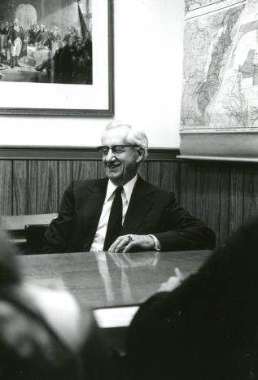 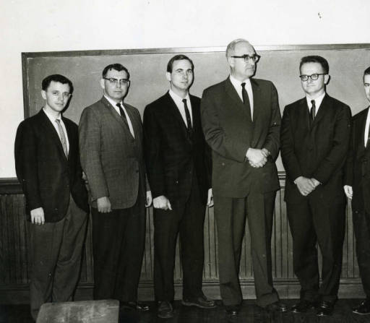

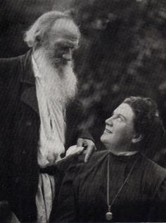 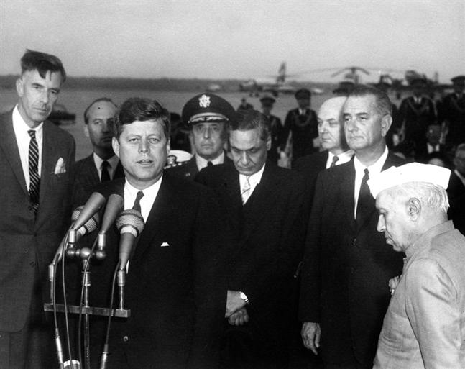

grad school UNC/Duke

Foust

NCSU/Greenlaw

Treml & Rosefielde

Brooks

& his students Bello and Justesen

later...

Bill Bowsky

Barry Beyer

Robin Winks

Ted Rabb

characteristics--good somewhat formal lecturers

brought in guest speakers